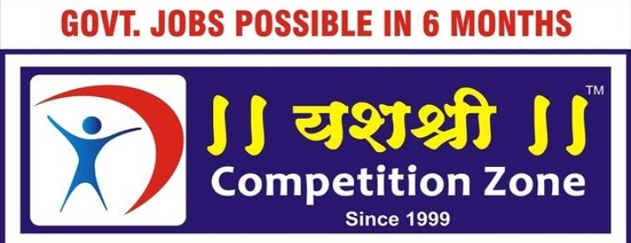

New reality: On Saudi Arabia-Iran reconciliation and China’s role

The Saudi-Iran reconciliation in a China-brokered agreement reflects the new reality in West Asia where old rivals are warming up to each other and Beijing is increasingly willing to play a bigger role at a time when the U.S., the region’s traditional great power, is preoccupied with challenges elsewhere. The enmity between Iran, a Shia-majority theocracy, and Saudi Arabia, a Sunni-majority absolute monarchy, has been one of the dominant drivers of conflicts in the region. While the details are yet to be unveiled, officials say Iran has agreed to prevent attacks against Saudi Arabia, including those from the Houthi-controlled parts of Yemen, and both countries would restore full diplomatic relations, which were severed in 2016. In recent years, West Asia has seen similar realignments. In 2020, the UAE was among the first Arab countries to normalise ties with Israel in a quarter century. The following years saw the Arab world and Israel, faced with the common Iran challenge, deepening their cooperation, despite Israel’s brutal occupation of Palestine territory. As the U.S. has deprioritised West Asia — it is now heavily focused on Ukraine and countering China’s Indo-Pacific influence — its allies in West Asia have started looking out for solutions for what they see as America’s diminishing security guarantees.
The agreement also marks China’s arrival in West Asia as a power broker. China has been involved in multilateral peace talks such as the 2015 Iran nuclear deal (from which the U.S. unilaterally withdrew in 2018), but this is the first time Beijing is using its leverage directly to bring conflicting parties to reconciliation. Stability in West Asia, a major energy source, is essential for China, which is the world’s largest oil importer. And unlike the U.S., which has hostile ties with Iran, Beijing enjoys good ties with Tehran and Riyadh, as a leading oil buyer and trading partner, respectively. This has put China in a unique position to bring two of the region’s most significant powers closer. Saudi Arabia, which is undergoing rapid changes, wants peace in its neighbourhood, while Iran, which is under the U.S.-imposed sanctions, wants more diplomatic and economic openings. If the détente holds, it will have far-reaching implications on regional geopolitics, from peace in Yemen to stability in Lebanon. But it is too early to say whether peace would hold between the two, given their multilayered enmity. Saudi Arabia, Iran and China should be mindful of the pitfalls ahead and continue to build on the momentum created now to achieve a cold peace between the two regional powers.

