ISRO successful in key test for India’s third moon mission
The Indian Space Research Organisation (ISRO) has successfully conducted the flight acceptance hot test of the CE-20 cryogenic engine that will power the Cryogenic Upper Stage of the LVM3 launch vehicle for the Chandrayaan-3 mission.The space agency said the test was successfully conducted on February 24, at the ISRO Propulsion Complex, Mahendragiri in Tamil Nadu.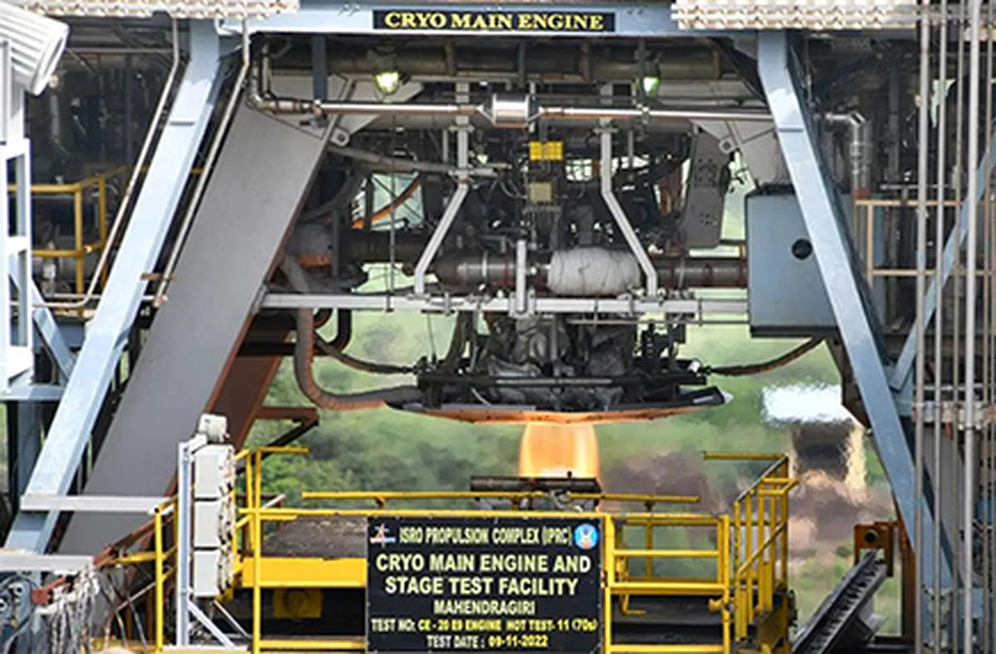
The CE-20 cryogenic engine. Photo: Special Arrangement
“The hot test was carried out for a planned duration of 25 seconds at the High Altitude Test Facility. All the propulsion parameters during the test were found satisfactory and closely matched with predictions. The cryogenic engine will be further integrated with the propellant tanks, stage structures and associated fluid lines to realise the fully integrated flight cryogenic stage,” ISRO said.

Three major modules
This flight acceptance hot test of the CE-20 cryogenic engine comes a day after the Chandrayaan-3 lander successfully completed the crucial EMI-EMC (Electromagnetic Interference/ Electromagnetic Compatibility) test at the U.R. Rao Satellite Centre in Bengaluru.
Chandrayaan-3 interplanetary mission has three major modules — the Propulsion module, Lander module and Rover. The mission’s complexity calls for establishing radio-frequency (RF) communication links between the modules.
Chandrayaan-3 is India’s third moon mission and is a follow-on mission to Chandrayaan-2 to demonstrate end-to-end capability in safe landing and roving on the lunar surface. The mission is slated to be launched later this year by Launch Vehicle Mark 3 (LMV3) from the Satish Dhawan Space Centre at Sriharikota.
- ISRO has successfully conducted the flight acceptance hot test of the CE-20 cryogenic engine that will power the Cryogenic Upper Stage of the LVM3 launch vehicle for the Chandrayaan-3 mission.
- The space agency said the test was successfully conducted on February 24, at the ISRO Propulsion Complex, Mahendragiri in Tamil Nadu.
- The mission is slated to be launched later this year by Launch Vehicle Mark 3 (LMV3) from the Satish Dhawan Space Centre at Sriharikota.

